Architecture Of   
AI-Powered Data Analysis System

Revision Number: 1.8

Last date of revision: 22/08/2024

**BY :- VIRAJ TUPE**

**Overview of System Architecture**

The AI-Powered Data Analysis System is meticulously designed to ensure that each aspect of the system is managed by a dedicated module, enabling clear separation of concerns. This modular architecture not only enhances scalability and maintainability but also simplifies the development and integration of new features. Below is a detailed description of the system architecture, including its components and their interactions.

**Architecture Diagram**

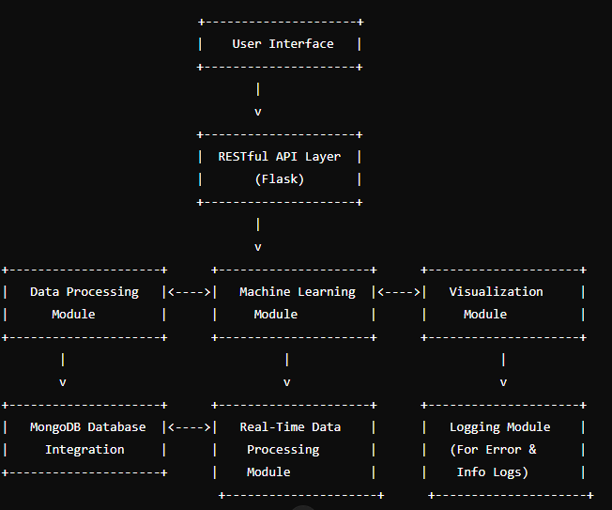

**Description of Components**

**1. User Interface**

* **Function:** Serves as the front-end layer through which users interact with the system. This interface can be a web-based application, a desktop client, or a mobile app.
* **Features:**
  + **Interactive Dashboard:** Allows users to upload datasets, initiate analyses, and view results.
  + **User Inputs:** Provides forms for data input, model selection, and configuration settings.
  + **Results Display:** Shows the output of data analysis, including visualizations and performance metrics.

**2. RESTful API Layer (Flask)**

* **Function:** Acts as the intermediary between the user interface and the backend modules. It processes HTTP requests, routes them to the appropriate module, and returns responses.
* **Features:**
  + **Endpoints:** Handles requests for data upload, model analysis, and results retrieval.
  + **Data Exchange:** Facilitates communication in JSON format, making it compatible with various front-end technologies.
  + **Authentication & Authorization:** Ensures secure access to the system by implementing user authentication and authorization mechanisms.

**3. Data Processing Module**

* **Function:** Manages the ingestion, cleaning, and preparation of data to ensure it is suitable for analysis.
* **Components:**
  + **Data Ingestion:** Handles the loading of data from CSV files or other formats into a structured format (e.g., Pandas DataFrame).
  + **Data Cleaning:** Performs tasks such as handling missing values, removing duplicates, and correcting inconsistencies.
  + **Data Transformation:** Prepares data by feature scaling, encoding categorical variables, and splitting datasets into training and testing sets.

**4. Machine Learning Module**

* **Function:** Focuses on building, training, and evaluating machine learning models using the processed data.
* **Components:**
  + **Model Training:** Implements algorithms like linear regression, decision trees, or neural networks, depending on the application.
  + **Model Evaluation:** Assesses model performance using metrics such as Mean Squared Error (MSE), R-squared, and confusion matrices.
  + **Model Selection:** Allows for the selection of the best-performing model based on evaluation results.

**5. Visualization Module (Optional)**

* **Function:** Generates visual representations of data and model results to aid in interpretation and decision-making.
* **Components:**
  + **Charts and Graphs:** Creates plots such as histograms, scatter plots, and bar charts.
  + **Interactive Dashboards:** Provides interactive visualizations that allow users to explore data and results dynamically.

**6. Database Integration (MongoDB)**

* **Function:** Manages data storage and retrieval, ensuring efficient data handling and persistence.
* **Components:**
  + **Database Connection:** Establishes and maintains a connection to the MongoDB database.
  + **Data Storage:** Stores raw data, processed data, model parameters, and analysis results.
  + **Data Retrieval:** Provides mechanisms to query and retrieve stored data for analysis or reporting.

**7. Real-Time Data Processing Module (Optional)**

* **Function:** Handles the ingestion and processing of real-time data streams for dynamic and up-to-date analysis.
* **Components:**
  + **Stream Processing:** Processes data in real time as it is received, enabling immediate analysis and response.
  + **Integration with APIs:** Connects with external data sources or APIs for real-time data input.

**8. Logging Module**

* **Function:** Manages the logging of system events, errors, and informational messages to support monitoring and debugging.
* **Components:**
  + **Error Logging:** Captures errors encountered during various stages of the system’s operation.
  + **Activity Logging:** Records user interactions, system processes, and performance metrics.
  + **Log Management:** Provides tools for reviewing and analyzing logs to troubleshoot issues and improve system performance.

**System Interactions**

1. **User Interaction:** Users interact with the system through the User Interface, where they can upload data, initiate analyses, and view results.
2. **API Communication:** The RESTful API Layer receives user requests and forwards them to the appropriate backend modules for processing.
3. **Data Handling:** The Data Processing Module manages data ingestion and preparation, which is then fed into the Machine Learning Module for model building and evaluation.
4. **Result Storage:** Processed data and model results are stored in the MongoDB database for future reference and retrieval.
5. **Visualization:** If implemented, the Visualization Module generates graphical representations of data and results for user analysis.
6. **Real-Time Processing:** The Real-Time Data Processing Module handles live data inputs and provides instantaneous analysis.
7. **Logging:** The Logging Module records all critical events and errors, providing valuable insights for system maintenance and improvement.

This detailed overview of the system architecture illustrates the comprehensive and modular design of the AI-Powered Data Analysis System. Each component plays a vital role in ensuring the system’s functionality, scalability, and user experience.

**6. System Architecture Diagram**

The system architecture for the AI-powered data analysis platform includes several key modules that interact to provide a seamless user experience. Below is an overview of the architecture:

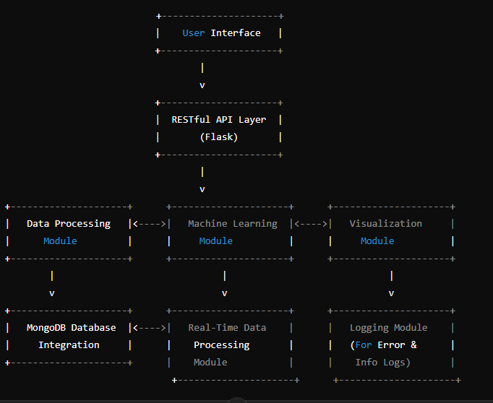

**7. Wireframe Documentation**

**1. API Endpoint Layout:**

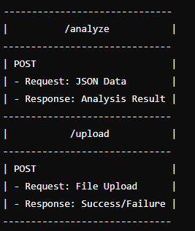

2. User Interface Layout (if developed as a web app):

